Kite

Definition
# Source: AI Source: Provided by: [Data Path: Persons Table -> ID Column: 1, Name_En Column: Motasem Essam] -> From: [ChatGPT] on [7/25/2026]
A kite is a quadrilateral with two distinct pairs of adjacent congruent sides.
For kite $ABCD$, a common arrangement is
$$AB=AD$$
and
$$BC=CD.$$
The equal sides are adjacent because each pair shares a common vertex.
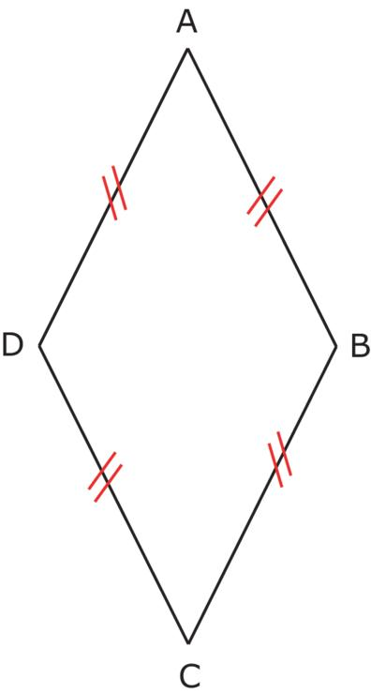
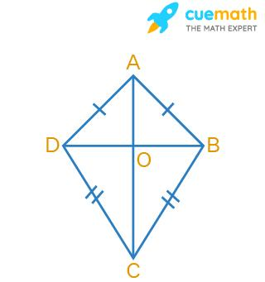
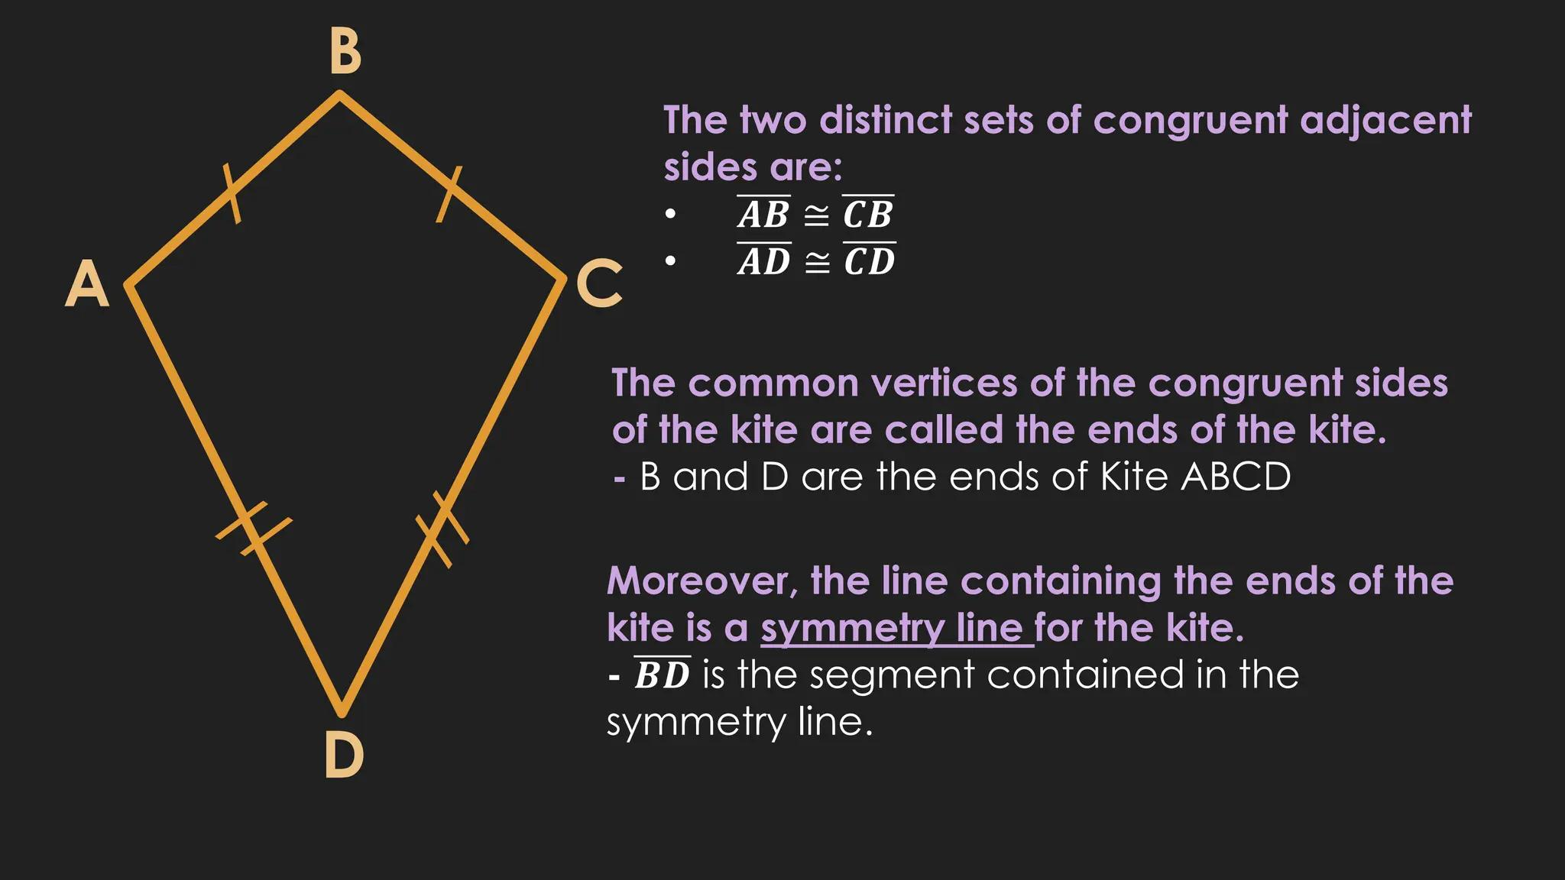
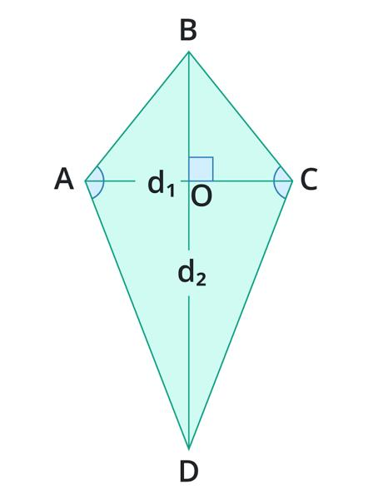
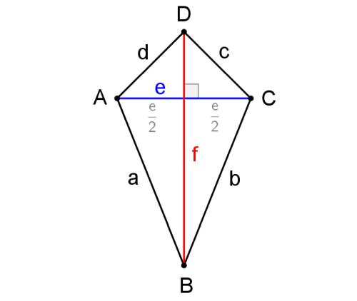

Purpose
# Source: AI Source: Provided by: [Data Path: Persons Table -> ID Column: 1, Name_En Column: Motasem Essam] -> From: [ChatGPT] on [7/25/2026]
A kite is useful for:
- Studying quadrilaterals with adjacent equal sides.
- Understanding perpendicular and symmetry relationships.
- Studying special properties of diagonals.
- Calculating area and perimeter.
- Applying congruent-triangle and symmetry concepts.
- Modeling shapes used in engineering, architecture, and design.

Fundamental Elements
# Source: AI Source: Provided by: [Data Path: Persons Table -> ID Column: 1, Name_En Column: Motasem Essam] -> From: [ChatGPT] on [7/25/2026]
Consider kite $ABCD$, where
$$AB=AD$$
and
$$BC=CD.$$

1. Vertices
# Source: AI Source: Provided by: [Data Path: Persons Table -> ID Column: 1, Name_En Column: Motasem Essam] -> From: [ChatGPT] on [7/25/2026]
The four vertices are
$$A, B, C, D.$$

2. Sides
# Source: AI Source: Provided by: [Data Path: Persons Table -> ID Column: 1, Name_En Column: Motasem Essam] -> From: [ChatGPT] on [7/25/2026]
The four sides are
$$\overset{‾}{AB}, \overset{‾}{BC}, \overset{‾}{CD}, \overset{‾}{DA}.$$

3. Congruent Side Pairs
# Source: AI Source: Provided by: [Data Path: Persons Table -> ID Column: 1, Name_En Column: Motasem Essam] -> From: [ChatGPT] on [7/25/2026]
The two pairs of adjacent congruent sides are
$$\boxed{AB=AD}$$
and
$$\boxed{BC=CD}.$$

4. Diagonals
# Source: AI Source: Provided by: [Data Path: Persons Table -> ID Column: 1, Name_En Column: Motasem Essam] -> From: [ChatGPT] on [7/25/2026]
The diagonals are
$$\overset{‾}{AC}$$
and
$$\overset{‾}{BD}.$$
The diagonal connecting the vertices where the equal sides meet is $AC$.
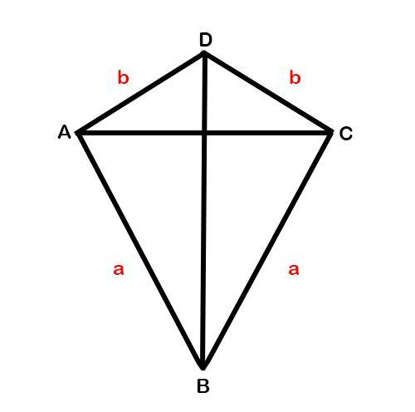
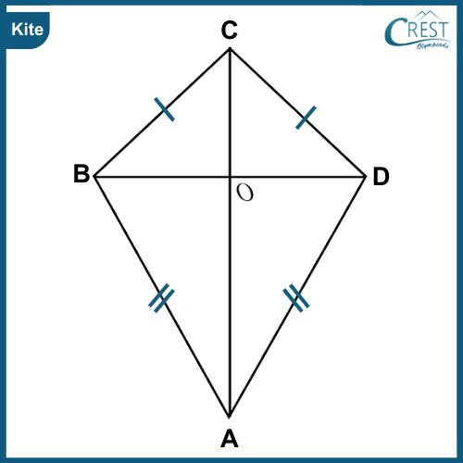
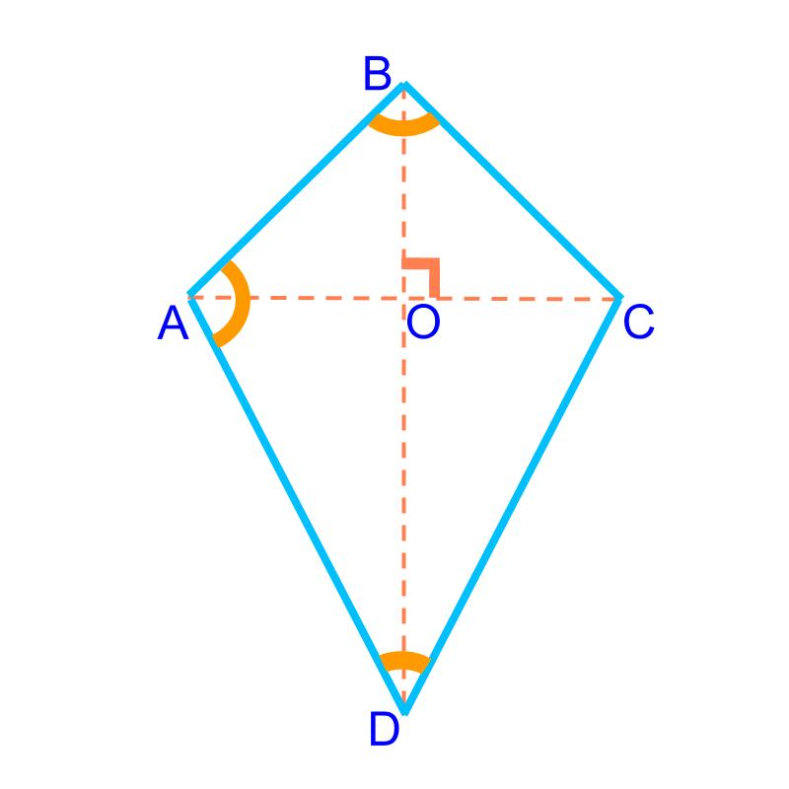
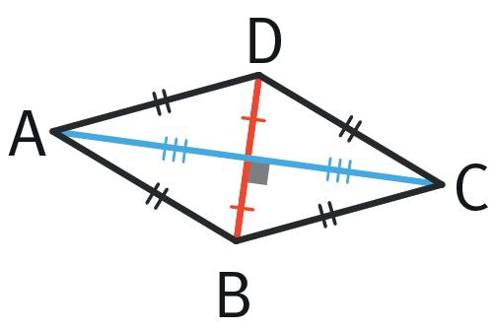

Main Properties
# Source: AI Source: Provided by: [Data Path: Persons Table -> ID Column: 1, Name_En Column: Motasem Essam] -> From: [ChatGPT] on [7/25/2026]
1. Two Pairs of Adjacent Congruent Sides
This is the defining property:
$$\boxed{AB=AD}$$
and
$$\boxed{BC=CD}.$$
The pairs are adjacent, not opposite.

2. Perpendicular Diagonals
The diagonals of a kite are perpendicular:
$$\boxed{AC⊥BD}.$$
Therefore, they intersect at a right angle:
$$\boxed{{90}^{∘}}.$$

3. One Diagonal Bisects the Other
The diagonal connecting the vertices between the equal side pairs bisects the other diagonal.
If
$$AC∩BD=O,$$
then
$$\boxed{BO=DO}.$$
Thus, $AC$bisects $BD$.
However, $BD$does not generally bisect $AC$.

4. One Diagonal Bisects Opposite Angles
The diagonal $AC$also bisects the angles at $A$and $C$.
Therefore,
$$\boxed{∠BAC=∠CAD}$$
and
$$\boxed{∠BCA=∠ACD}.$$

5. One Pair of Opposite Angles Is Congruent
The angles between the unequal sides are congruent:
$$\boxed{∠B=∠D}.$$
This follows from the congruent triangles formed by the diagonal $AC$.

6. Line of Symmetry
A typical kite has one line of symmetry.
The symmetry axis is the diagonal connecting the vertices where the congruent sides meet:
$$\boxed{AC}.$$
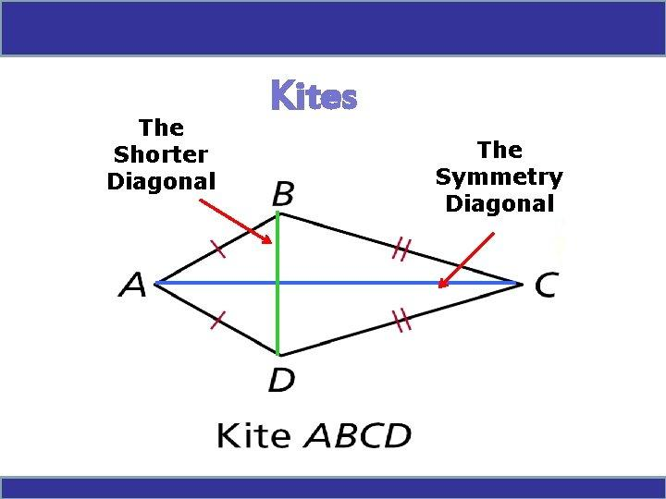
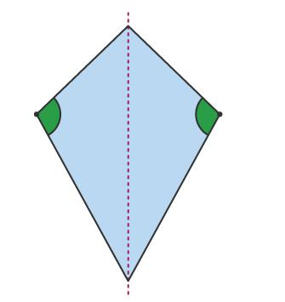
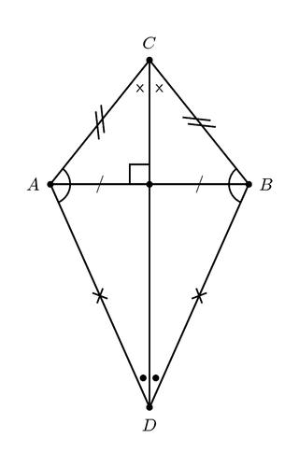
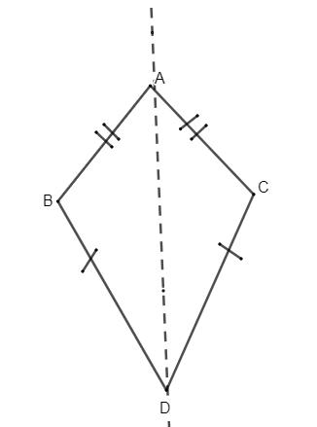

Mathematical Representation
# Source: AI Source: Provided by: [Data Path: Persons Table -> ID Column: 1, Name_En Column: Motasem Essam] -> From: [ChatGPT] on [7/25/2026]
Let the side lengths be
$$AB=AD=a$$
and
$$BC=CD=b.$$
Let the diagonals be
$$AC=d_{1}$$
and
$$BD=d_{2}.$$

Perimeter
# Source: AI Source: Provided by: [Data Path: Persons Table -> ID Column: 1, Name_En Column: Motasem Essam] -> From: [ChatGPT] on [7/25/2026]
The perimeter is
$$P=AB+BC+CD+DA.$$
Since
$$AB=AD=a$$
and
$$BC=CD=b,$$
we get
$$\boxed{P=2a+2b}$$
or
$$\boxed{P=2\left(a+b\right)}.$$

Area
# Source: AI Source: Provided by: [Data Path: Persons Table -> ID Column: 1, Name_En Column: Motasem Essam] -> From: [ChatGPT] on [7/25/2026]
Because the diagonals are perpendicular, the area is
$$\boxed{A=\frac{d_{1}d_{2}}{2}}.$$
Equivalently,
$$\boxed{A=\frac{AC⋅BD}{2}}.$$

Example 1 — Perimeter
# Source: AI Source: Provided by: [Data Path: Persons Table -> ID Column: 1, Name_En Column: Motasem Essam] -> From: [ChatGPT] on [7/25/2026]
Suppose a kite has
$$AB=AD=6\text{ cm}$$
and
$$BC=CD=9\text{ cm}.$$
Then
$$P=2\left(a+b\right) \\ P=2\left(6+9\right) \\ P=2\left(15\right) \\ \boxed{P=30\text{ cm}}.$$

Example 2 — Area
# Source: AI Source: Provided by: [Data Path: Persons Table -> ID Column: 1, Name_En Column: Motasem Essam] -> From: [ChatGPT] on [7/25/2026]
Suppose the diagonals of a kite are
$$AC=12\text{ cm}$$
and
$$BD=8\text{ cm}.$$
Then
$$A=\frac{d_{1}d_{2}}{2} \\ A=\frac{12×8}{2} \\ \boxed{A=48{\text{ cm}}^{2}}.$$

Example 3 — Diagonal Properties
# Source: AI Source: Provided by: [Data Path: Persons Table -> ID Column: 1, Name_En Column: Motasem Essam] -> From: [ChatGPT] on [7/25/2026]
Suppose
$$BD=14\text{ cm}$$
and the diagonals intersect at $O$.
Because $AC$bisects $BD$,
$$BO=DO.$$
Therefore,
$$BO=\frac{14}{2}$$
so
$$\boxed{BO=DO=7\text{ cm}}.$$

Kite and Right Triangles
# Source: AI Source: Provided by: [Data Path: Persons Table -> ID Column: 1, Name_En Column: Motasem Essam] -> From: [ChatGPT] on [7/25/2026]
Because the diagonals are perpendicular, they divide the kite into four right triangles.
For example, if the intersection point is $O$, then
$$∠AOB=∠BOC=∠COD=∠DOA={90}^{∘}.$$
This makes the Pythagorean theorem useful for finding unknown side lengths.
For example,
$$AB^{2}=AO^{2}+BO^{2}.$$
Similarly,
$$BC^{2}=BO^{2}+CO^{2}.$$

Kite vs. Rhombus
# Source: AI Source: Provided by: [Data Path: Persons Table -> ID Column: 1, Name_En Column: Motasem Essam] -> From: [ChatGPT] on [7/25/2026]
A rhombus has four congruent sides:
$$AB=BC=CD=DA.$$
A general kite has two pairs of adjacent congruent sides:
$$AB=AD$$
and
$$BC=CD.$$
Therefore:
$$\boxed{\text{Every rhombus is a kite under the inclusive definition}}$$
because it satisfies the adjacent-pair condition.
However, some textbooks define a kite as having exactly two distinct pairs of adjacent congruent sides. Under that convention, a rhombus is not classified as a kite.
For a mathematics knowledge base, it is best to explicitly state which convention is being used.

Kite vs. Other Quadrilaterals
# Source: AI Source: Provided by: [Data Path: Persons Table -> ID Column: 1, Name_En Column: Motasem Essam] -> From: [ChatGPT] on [7/25/2026]
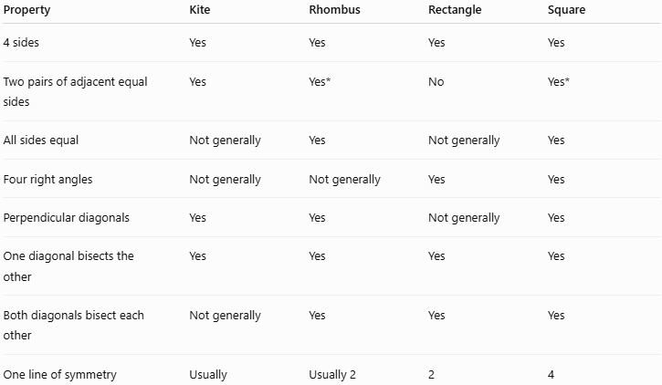
Property | Kite | Rhombus | Rectangle | Square
4 sides | Yes | Yes | Yes | Yes
Two pairs of adjacent equal sides | Yes | Yes* | No | Yes*
All sides equal | Not generally | Yes | Not generally | Yes
Four right angles | Not generally | Not generally | Yes | Yes
Perpendicular diagonals | Yes | Yes | Not generally | Yes
One diagonal bisects the other | Yes | Yes | Yes | Yes
Both diagonals bisect each other | Not generally | Yes | Yes | Yes
One line of symmetry | Usually | Usually 2 | 2 | 4
$*$Under the inclusive definition.

Kite vs. Parallelogram
# Source: AI Source: Provided by: [Data Path: Persons Table -> ID Column: 1, Name_En Column: Motasem Essam] -> From: [ChatGPT] on [7/25/2026]
A general kite is not a parallelogram.
A parallelogram has two pairs of opposite parallel sides:
$$AB∥CD$$
and
$$AD∥BC.$$
A kite instead is defined by adjacent congruent sides.
However, a rhombus can satisfy both descriptions.

Special Case: Square
# Source: AI Source: Provided by: [Data Path: Persons Table -> ID Column: 1, Name_En Column: Motasem Essam] -> From: [ChatGPT] on [7/25/2026]
A square has four equal sides:
$$AB=BC=CD=DA$$
and four right angles.
Therefore, under the inclusive kite definition, a square also satisfies the kite side condition.
So a square can be considered a special case of a kite, as well as a:
- rectangle
- rhombus
- parallelogram
- quadrilateral
- regular polygon

Real-World Applications
# Source: AI Source: Provided by: [Data Path: Persons Table -> ID Column: 1, Name_En Column: Motasem Essam] -> From: [ChatGPT] on [7/25/2026]
Kite-shaped geometry appears in:
- Flying kites
- Decorative patterns
- Jewelry designs
- Architecture
- Floor and wall patterns
- Road and warning-sign designs
- Engineering components
- Tiling and tessellations
- Graphic and logo design

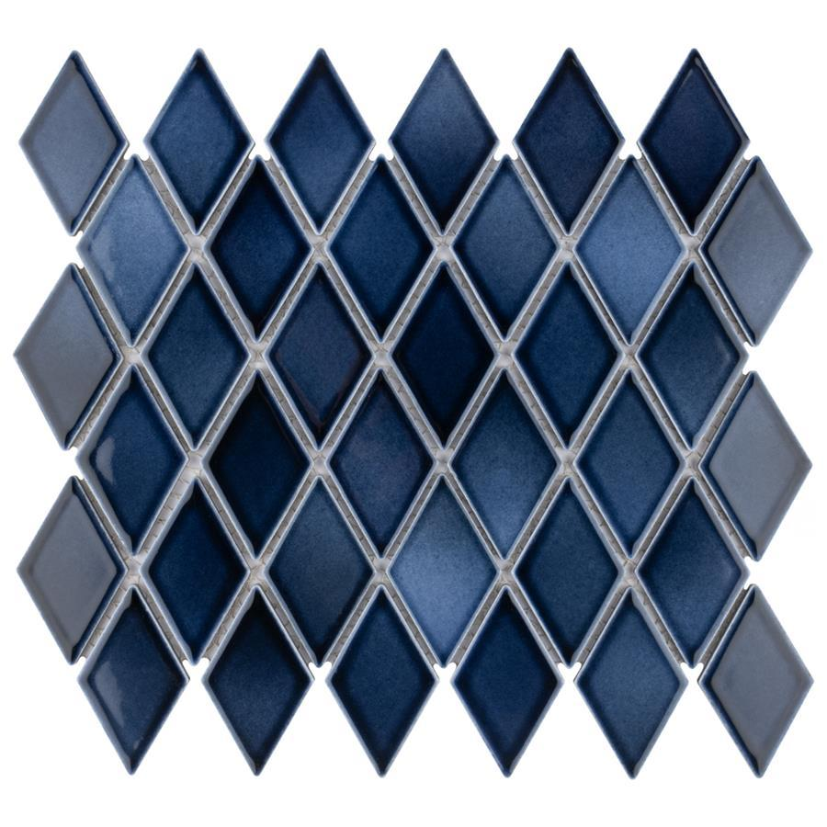
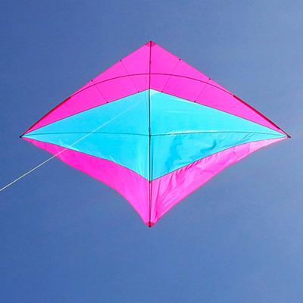

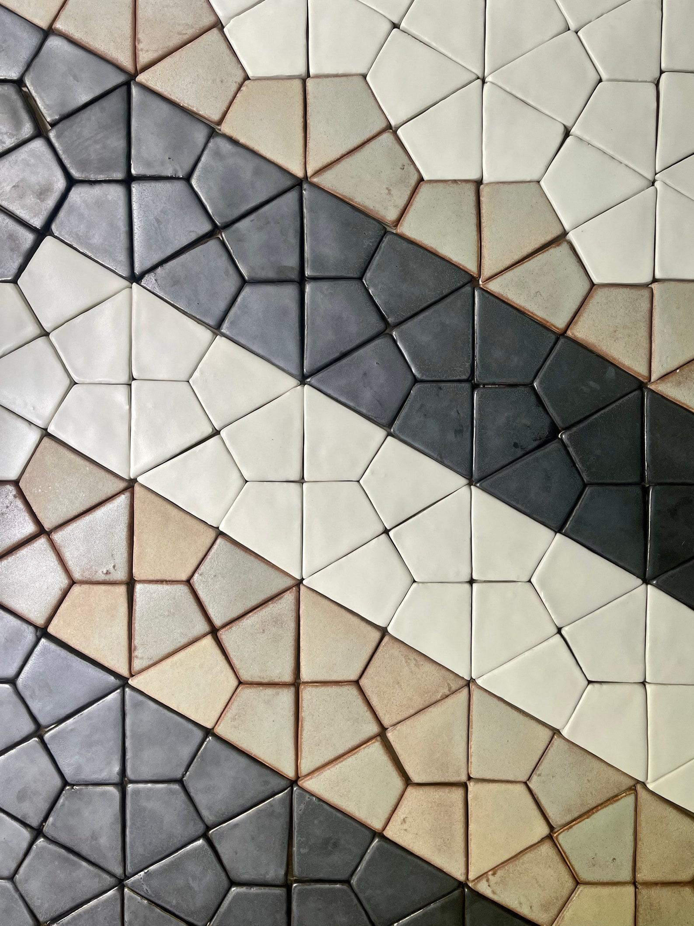
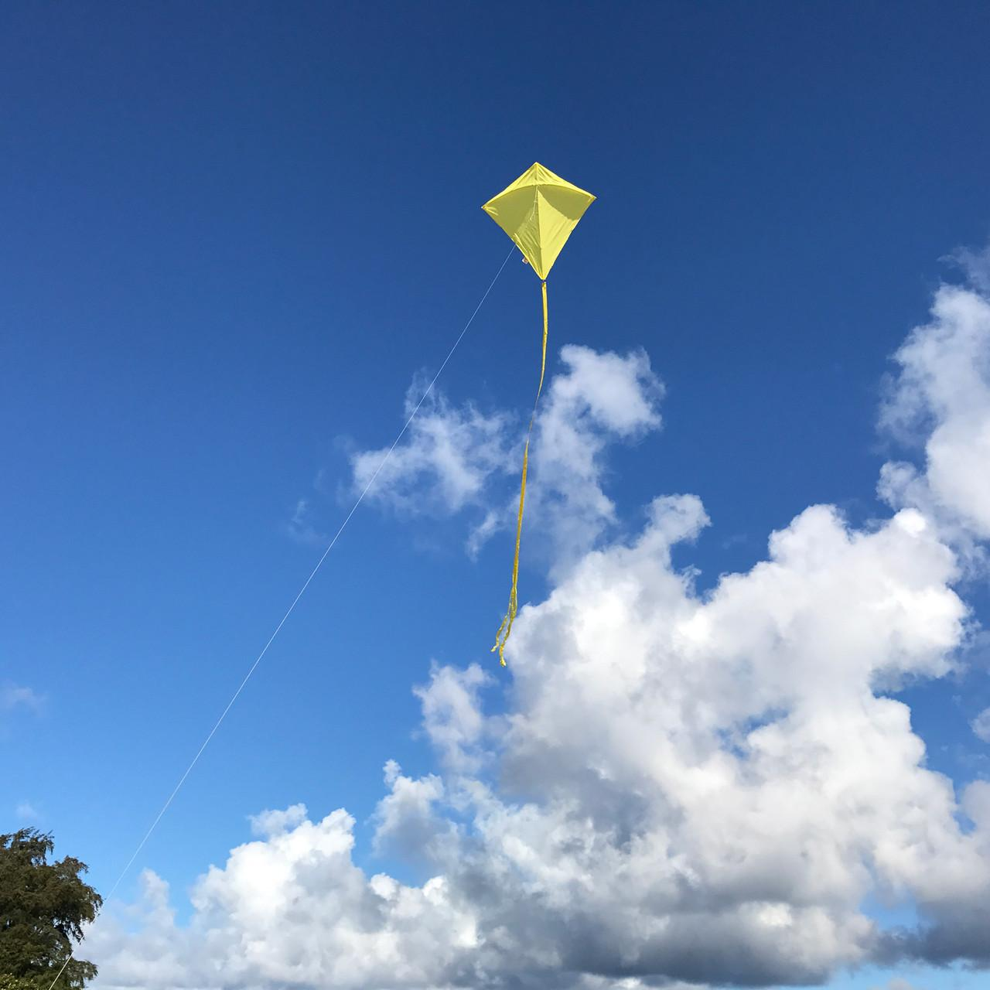

Advantages
# Source: AI Source: Provided by: [Data Path: Persons Table -> ID Column: 1, Name_En Column: Motasem Essam] -> From: [ChatGPT] on [7/25/2026]
- Simple side-congruence definition.
- Perpendicular diagonals make area calculations easy.
- Symmetry can simplify geometric problems.
- Can be divided into right triangles.
- Useful for applying the Pythagorean theorem.
- Appears naturally in many geometric and real-world designs.

Limitations
# Source: AI Source: Provided by: [Data Path: Persons Table -> ID Column: 1, Name_En Column: Motasem Essam] -> From: [ChatGPT] on [7/25/2026]
A general kite does not necessarily have:
- Four equal sides.
- Four right angles.
- Two pairs of parallel sides.
- Diagonals that bisect each other.
- Congruent diagonals.
- Rotational symmetry.

Key Points
# Source: AI Source: Provided by: [Data Path: Persons Table -> ID Column: 1, Name_En Column: Motasem Essam] -> From: [ChatGPT] on [7/25/2026]
- A kite is a quadrilateral with two pairs of adjacent congruent sides.
- Typical notation:
$$\boxed{AB=AD, BC=CD}$$
- Its diagonals are perpendicular:
$$\boxed{AC⊥BD}$$
- One diagonal bisects the other:
$$\boxed{BO=DO}$$
- One diagonal bisects a pair of opposite angles.
- One pair of opposite angles is congruent:
$$\boxed{∠B=∠D}$$
- Area:
$$\boxed{A=\frac{d_{1}d_{2}}{2}}$$
- Perimeter:
$$\boxed{P=2\left(a+b\right)}$$
- A typical kite has one line of symmetry.
- A rhombus and square may also be classified as kites under the inclusive definition.

Conclusion
# Source: AI Source: Provided by: [Data Path: Persons Table -> ID Column: 1, Name_En Column: Motasem Essam] -> From: [ChatGPT] on [7/25/2026]
A Kite is a quadrilateral characterized by two pairs of adjacent congruent sides. Its most important geometric properties are its perpendicular diagonals, the fact that one diagonal bisects the other, and its symmetry. Its perpendicular diagonals also provide the convenient area formula
$$\boxed{A=\frac{d_{1}d_{2}}{2}}.$$
In your quadrilateral taxonomy, Kite should be placed alongside Trapezoid and Parallelogram as a major quadrilateral type, with Isosceles Trapezoid and Right Trapezoid as the special trapezoid types.
Would you like the kite section rewritten in the same concise style as the right trapezoid section?

